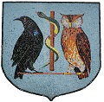
RAMSEY GROUP PRACTICE LLC
IT’S THAT TIME OF YEAR AGAIN – FLU SEASON
FRIDAY 29TH SEPTEMBER 2023 FROM 8AM
FRIDAY 13TH OCTOBER 2023 FROM 8AM
RAMSEY COURT HOUSE
POP ALONG AND SEE US IF YOU ARE ELIGIBLE FOR AN NHS FLU VACCINATION. FOR ELIGIBILITY SEE GOV.IM/FLU
